SHORTEST JS Program χ●window & this keyword

21 November 2023 20:08

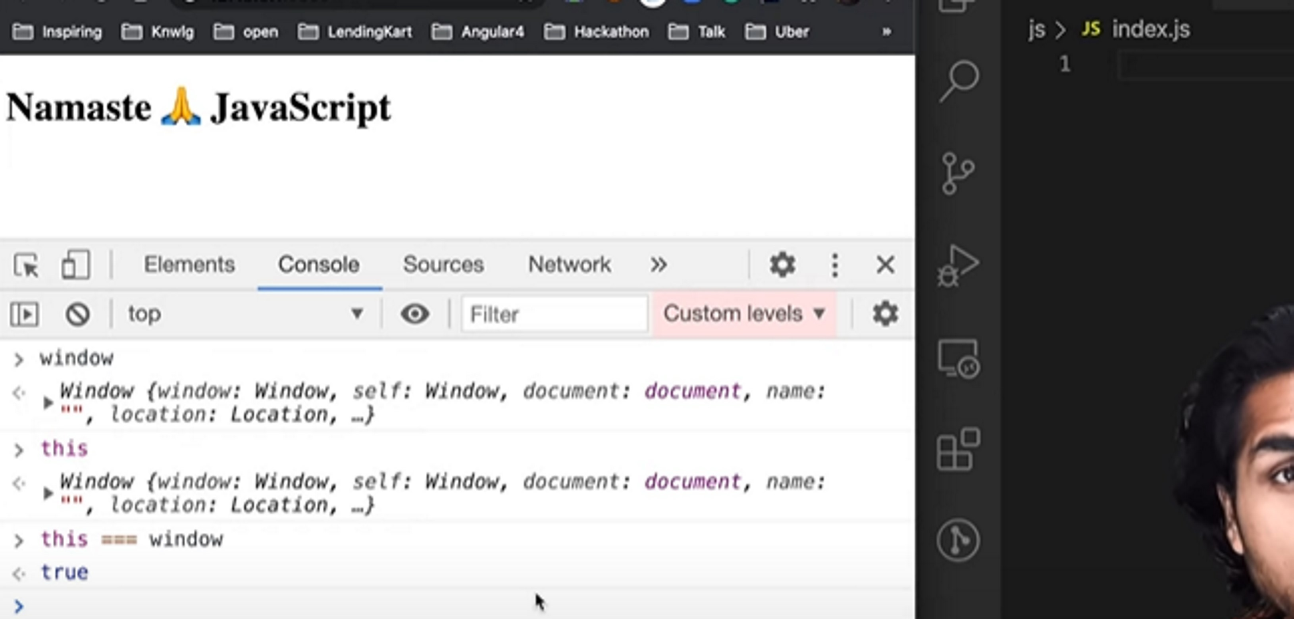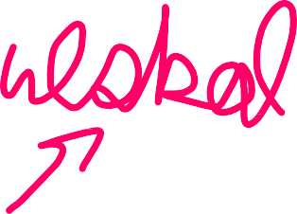

Global space:- any thing not inside fun().